**Roll Off Project**

Low Level Design

Date:17/02/2022

**Roll Off (LLD)**

|  |  |
| --- | --- |
| Role | Functions |
| Account Team | Account Team initiate roll off with reason for particular employee. |
| PSP Team | PSP team will check reasons of roll off and decide whether to approved it or not. If it rejects, it will get back to accounts team. Now it is upto Accounts team to decide whether to forward it to Super admin or decline his roll off. |
| Super Admin | If employee is from A grade level or his notice period < 30 days or roll off request is declined by PSP team and accounts team wants to reconsider then super admin will have access to approve it or not. |

# Project Background, Objective(s)

## Project Background

Roll Off project is implemented to make roll off process easier for all department and it is very easy to maintain all process from initiating roll off until approved roll off. It is very time saving as all process is done using a single system.

## Project Objective

The main objective of Roll Off is to act as bridge amongst departments i.e Account team, PSP team and Super admin. By registering, user will search employee and will be able to make roll off using accurate reasons.

# Solution Diagram

# Architecture Diagram

# 

# 7.0 Use case Diagram:

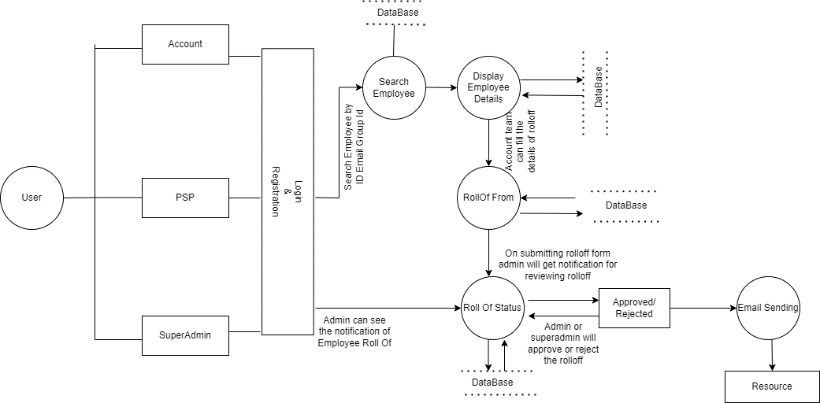

**8.0 Flow Diagram**

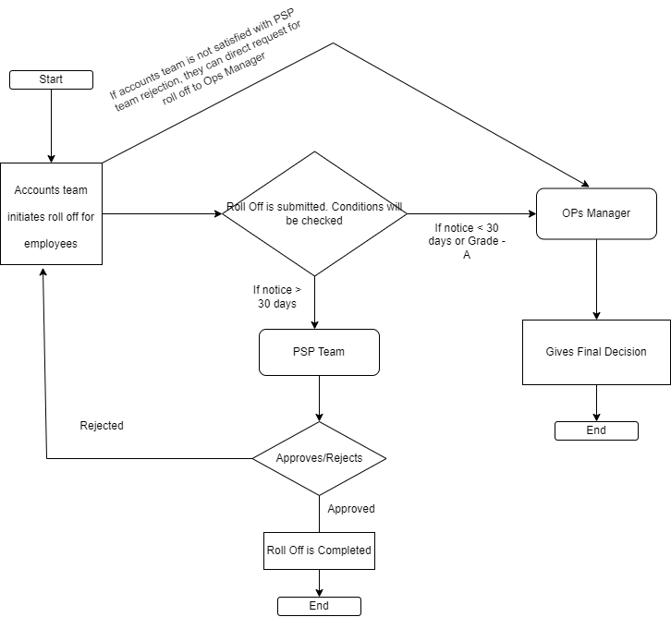

# 9.0 Class Diagram

# 10.0 E-R Diagram:

# 11.0 User Requirements

# 11.1 Hardware

# • Processor: Minimum 1.8 GHz. Recommended 2GHz or more.

# • Ethernet connection (LAN) OR a wireless adapter (Wi-Fi)

# • Hard Drive: Minimum 100 GB; Recommended 500GB or more.

# • Memory (RAM): Minimum 4 GB; Recommended 8 GB or above.

# • OS: Windows.

# 11.2 Software

# • Any Latest Browsers.

# 12.0 Developer Requirements

# 12.1 Hardware

# • Processor: Minimum 1.8 GHz. Recommended 2GHz or more.

# • Ethernet connection (LAN) OR a wireless adapter (Wi-Fi)

# • Hard Drive: Minimum 100 GB; Recommended 500GB or more.

# • Memory (RAM): Minimum 4 GB; Recommended 8 GB or above.

# • OS: Windows.

# 12.2 Software

# • Visual studio 2019.

# •Sql server management studio (ssms).

# • ASP .NET Web Api, Angular.

# 12.3 Technology

# • ASP.NET for backend

# •SQL for the database operations

# • Angular for frontend.

# 13.0 Solution Steps

**13.1 User Registration**

1. The user will select their role as Account team, PSP team and Super Admin.
2. The user will enter the name, email, role and password during registration.
3. The input validation will be done
4. If validation fails, then it will return the error code and error description. with status code
5. If validation is successful, then the User details is stored in the database and success code is sent.

**13.2 Employee List**

1. Employee details
2. User will search employee from employee list using global group id and email and send request for roll off of employee.
3. After that user will submit roll off form with roll off reasons.

**13.3 Roll Off Form**

1. Roll Off form contain reasons for roll off.
2. User fill the roll off form and give feedback of particular employee.

**13.4 Approving Roll Off**

1. Psp team decide whether to approve it or not.
2. If psp team reject form it the request goes to account team.
3. If employee is level A employee then request goes to super admin.

**13.5 Admin Module**

1. Admin will login with his Username and Password.
2. Admin can able to filter active/inactive farmers and dealers.
3. The admin can approve/ reject roll off .